Setup Guide VS Code for C++ with MinGW g++, gdb on Windows

1. Introduction

Required software | Purpose
Visual Studio Code | Source code editor
MinGW-w64 | C++ Compiler (g++)
gdb | Debugger
Microsoft C/C++ Extension | IntelliSense and Debugging

After completing this guide, you will be able to: write C++ programs; compile with g++; debug using gdb; and build projects inside Visual Studio Code

2. Install Visual Studio Code

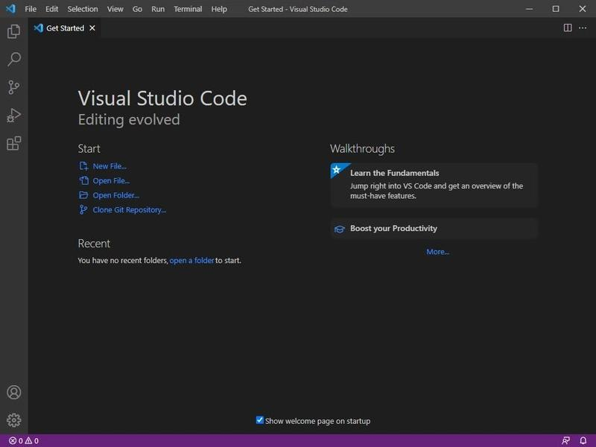

Step 1. Download Visual Studio Code from https://code.visualstudio.com/
Step 2. Run the installer Enable: Add to PATH, register Code as editor, add "Open with Code", and then click Next until installation finishes.
Step 3. Open Visual Studio Code Select the Extensions icon Search for:
C/C++ Install the extension published by Microsoft (e.g., IntelliSense).

3. Install MinGW-w64 (g++ and gdb)

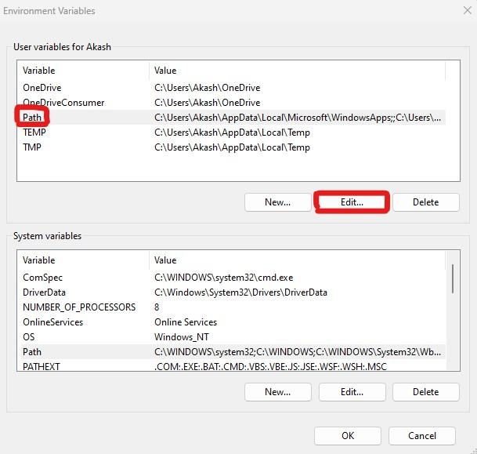

Step 1. Download MinGW-w64 Install it using the default settings Place under installation folder like “C:\mingw64”
Step 2. Locate the bin folder like “C:\mingw64\bin”
Step 3. Add the folder to the Windows PATH. Using: Control Panel System Advanced System Settings Environment Variables
Step 4. Open Command Prompt Type: g++ --version Output: g++ (MinGW-W64) 13.x.x Verify: gdb –version Expected: GNU gdb

4. Configure Compiler in VS Code

Step 1. Open View Command Palette (Ctrl + Shift + P)
Step 2. Select: C/C++: Edit Configurations (UI)
Step 3. Set Compiler Path to like C:/cpp/bin/g++.exe
Step 4. Set IntelliSense mode to gcc-x64 (legacy)
Step 5. Close C/C++ Configuration

c_cpp_properties.json file created automatically.

5. Create and compile your C++ project

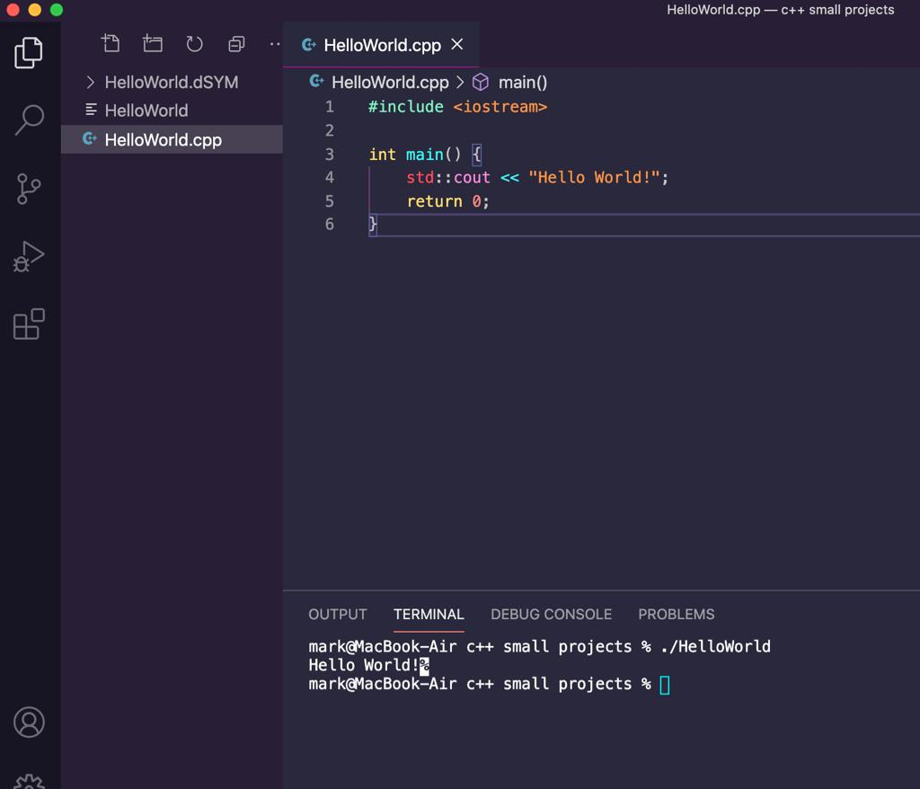

Step 1: Create a folder: CPPProjects Open it in VS Code.
Step 2: Create main.cpp
#include <iostream>
using namespace std;
int main()
{
cout << "Hello World!" << endl;
return 0;
}

Step 3 Open Terminal New Terminal Compile: g++ main.cpp -o main.exe
Run: main.exe Expected output: Hello World!

6. Configure debugger in VS Code

Step 1. Open Run Add configuration
Step 2. Choose More C++ (GDB/LLDB) options …
Step 3. Choose C/C++:g++.exe build and debug active file …
Step 4. Choose C/C++:g++.exe build and debug active file user settings…

A launch.json debug configuration is created by VS Code automatically. Then edit the launch.json file so it looks like the below:
{
"version": "0.2.0",
"configurations": [
{
"name": "(gdb) Launch",
"type": "cppdbg",
"request": "launch",
"program": "${workspaceFolder}/main.exe",
"args": [],
"stopAtEntry": false,
"cwd": "${fileDirname}",
"environment": [],
"externalConsole": false,
"MIMode": "gdb",
"miDebuggerPath": "C:\\cpp\\bin\\gdb.exe",
"setupCommands": [
{
"description": "Enable pretty-printing for gdb",
"text": "-enable-pretty-printing",
"ignoreFailures": true
},
{
"description": "Set Disassembly Flavor to Intel",
"text": "-gdb-set disassembly-flavor intel",
"ignoreFailures": true
}
]
}
]
}

7. Create Build Task

Step 1. Select your .cpp file Open View Command Palette (or Ctrl + Shift + P)
Step 2. Select: Tasks: Configure Default Build Task
Step 3. Choose: g++.exe build active file
tasks.json file created automatically. Then edit the tasks.json file so it looks like the below.
{
"version": "2.0.0",
"tasks": [
{
"label": "Build",
"type": "shell",
"command": "g++",
"args": [
"-o",
"main",
"-g",
"main.cpp"
],
"group": {
"kind": "build",
"isDefault": true
}
}
]
}

8. Build, Debug and Troubleshooting your program
- To Building the program:
Step 1. Open Terminal Run Build Task
Step 2. Press any key on the Terminal window

- Running the Debugger:
Step 1. Click in the left margin to create a breakpoint.
Step 2. Open Run Start Debugging (F5)
Step 3. Select C++ (gdb), if prompted.
Step 4. The program starts.
Step 5. Execution stops at the breakpoint.
Step 6. Open Run Step Over (F10) to continue troubleshooting 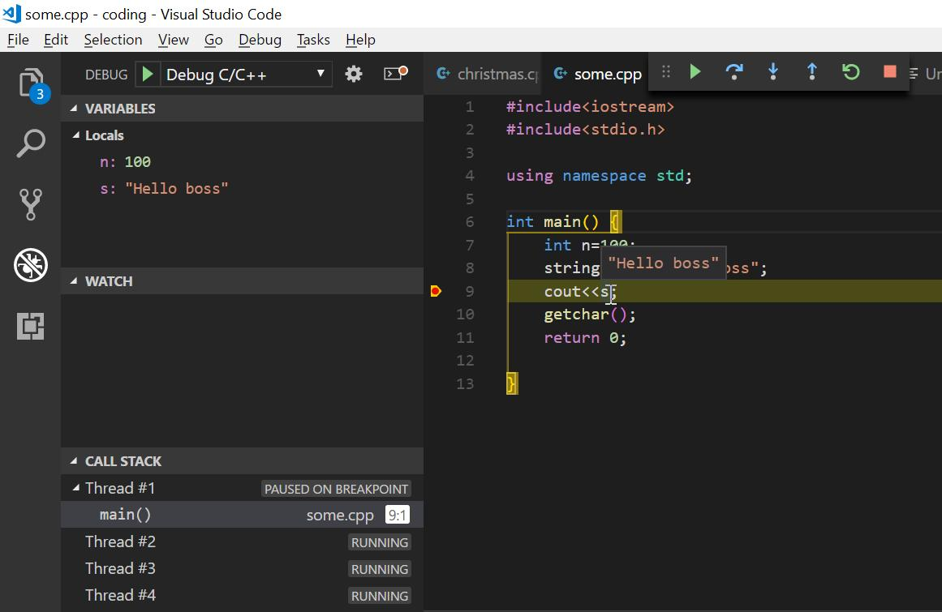

9. Additional resources:
- C++ Setup in VS Code with g++ and gdb on Windows 10
- C++ Setup in VS Code on Mac

